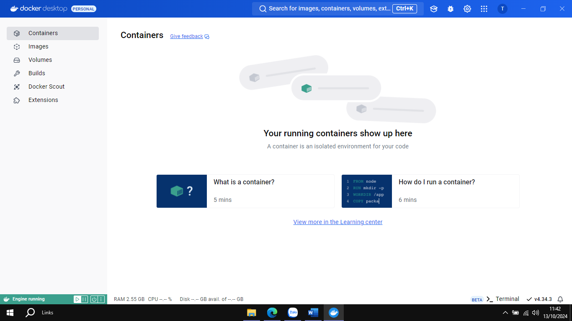

Chia sẻ lưu trữ trên docker hub

Tạo một không gian lưu trữ các Image

Docker chỉ cho 1 resp private

Tagname dùng để phân biệt các version phần mềm vì chỉ có một nơi để lưu trữ